# 1) REGISTER

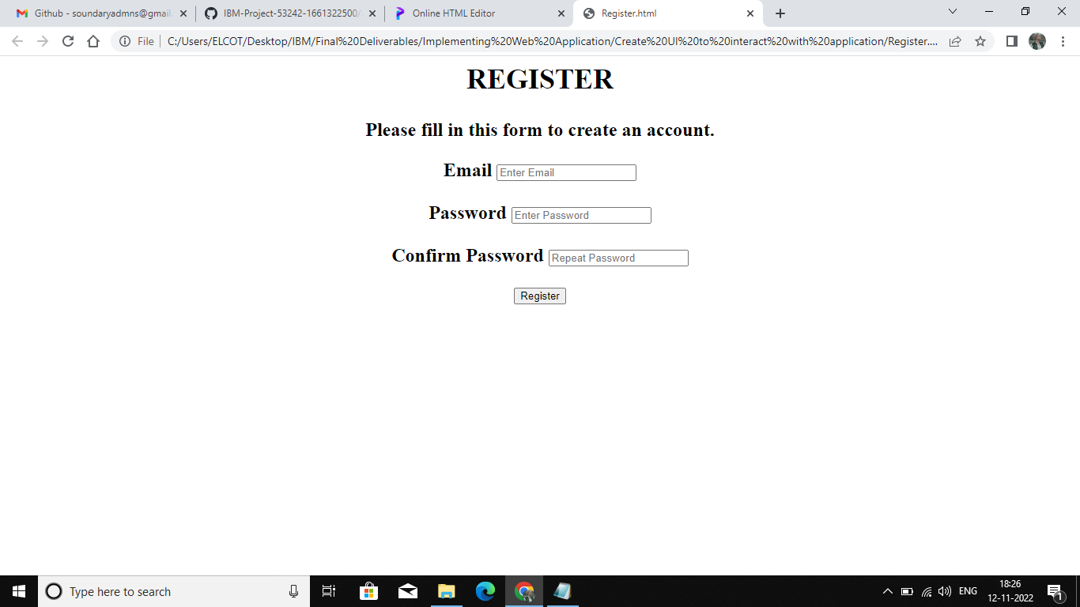

**VIEW HISTORY OF ITEMS**

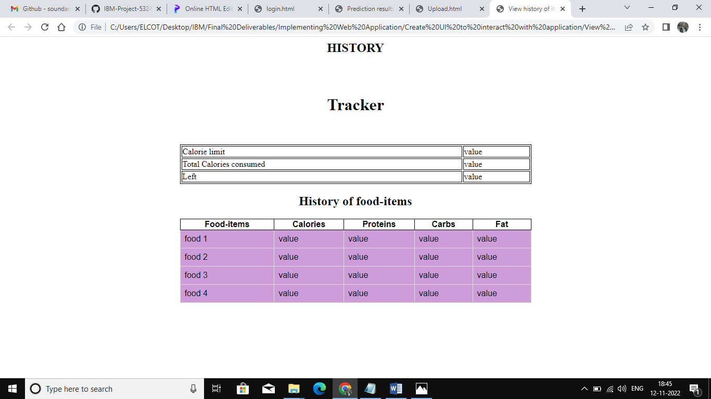

**UPLOAD IMAGE**

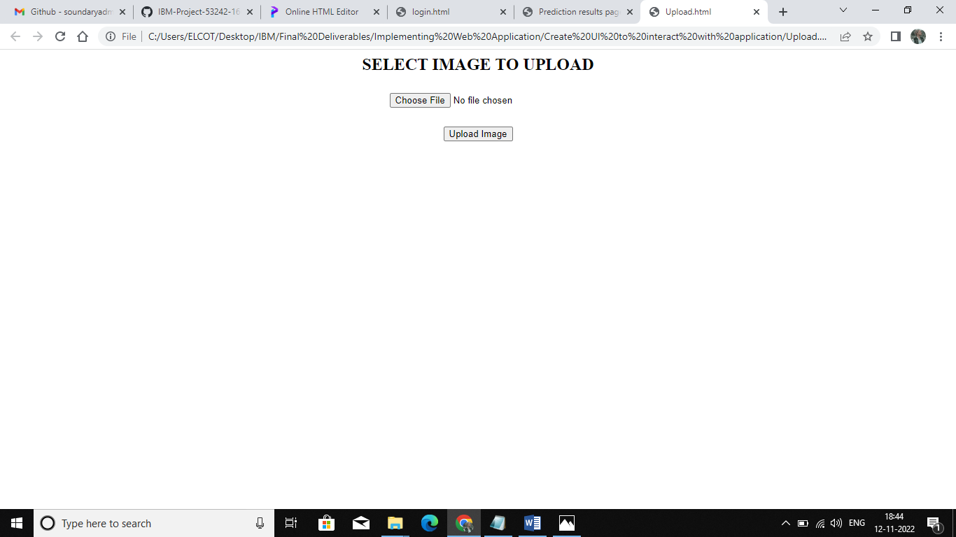

**PREDICTION RESULTS PAGE FOR FOOD ITEMS**

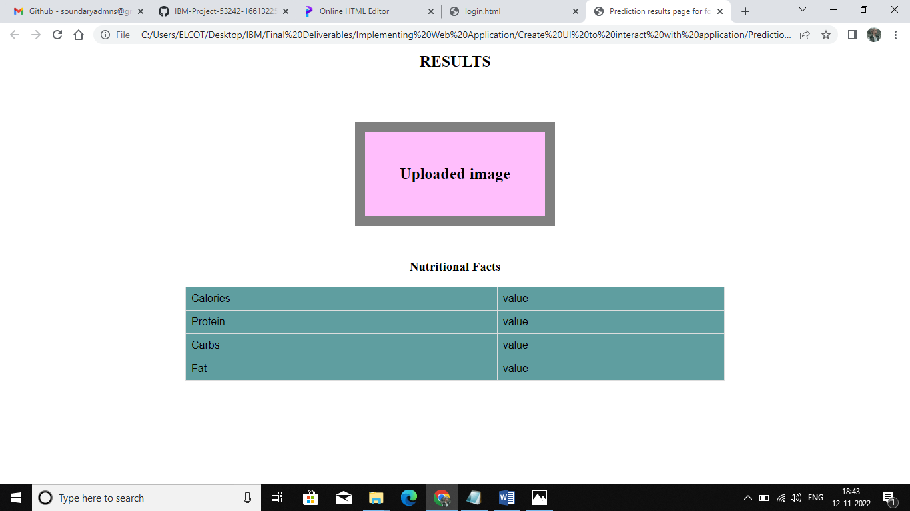

**LOGIN**

